Configure MFA Authentication — Microsoft Authenticator

Objective
Configure Multi-Factor Authentication (MFA) for the Contoso account using the Microsoft Authenticator app on a mobile device. This process is required for new users or when switching mobile devices.

Prerequisites
- Mobile device with Android or iOS available
- Internet access on the mobile device
- Contoso credentials (email @contoso.com and network password)
- Computer with a browser (Chrome, Edge, or Firefox)

Step-by-Step

On the mobile device
- Open the app store (Play Store on Android or App Store on iOS).
- Search for "Microsoft Authenticator" and install the app.
- Open the app after installation — no login is required at this point.

On the computer
- Open any browser and go to: myaccount.microsoft.com
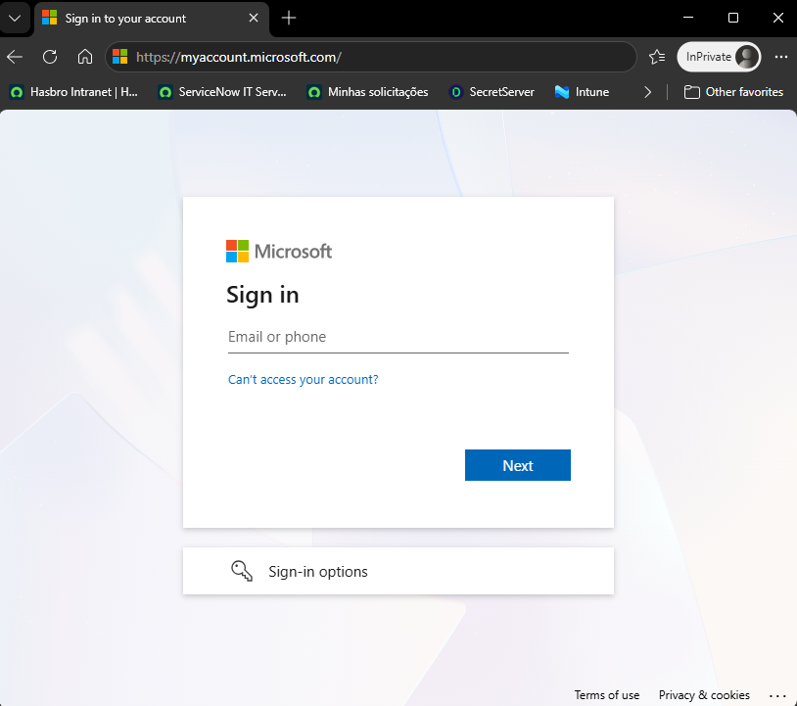
- Sign in with your Contoso credentials (email @contoso.com and network password).
- The website will automatically display the MFA setup wizard. Follow the steps below:

Guided setup via portal
- When prompted to download the Authenticator app, if it is already installed click Next.
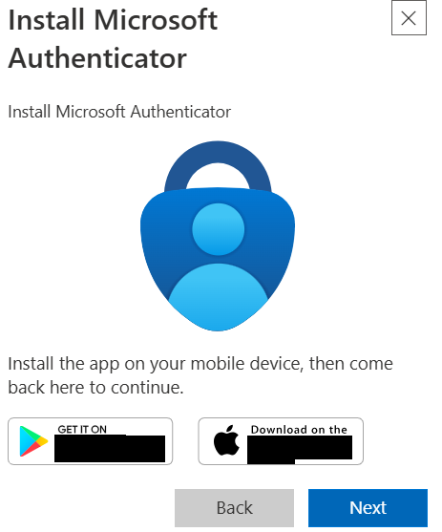
- On the next screen, a QR Code will be displayed on the computer.
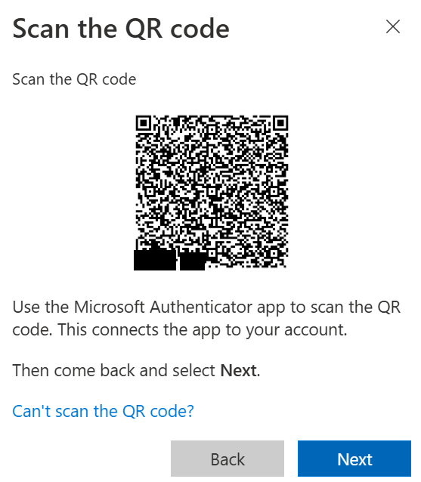
- On the mobile device, open Microsoft Authenticator, tap the QR CODE icon in the bottom-right corner, and scan the QR Code shown on the computer screen.
- After scanning, the Contoso account will appear in the app. On the computer, click "Next".
- The portal will send a push notification to the mobile device with a numeric code displayed on the screen.
- On the mobile device, tap the Authenticator notification and enter the code shown on the computer screen to confirm.
After confirmation, MFA will be configured. Click Finish. Then follow KB-016 to configure the PASSKEY.

⚠ If the QR Code cannot be scanned, the app also allows adding the account manually using the code displayed below the QR Code by clicking "Can't scan the QR Code?".
⚠ If the user already has Authenticator configured on another mobile device, the old device must be removed before configuring the new one — PERFORM REMOVAL THROUGH Entra ID.

Version History
Author | Version | Date | Description
Lucas Souza | 1.0 | May/2026 | Creation
Lucas Souza | 1.1 | Aug/2026 | Update

